**PROJECT ON CLASSIFICATION OF “IRIS” DATASET USING R-LANGUAGE**

BY KHUSHBOO KUMARI

**Classification:**

Classification is a type of supervised learning. It specifies the class to which data elements belong to and is best used when the output has finite and discrete values. It predicts a class for an input variable as well.

There are 2 types of Classification:

* Binomial
* Multi-Class

**CODE:**

> data("iris")

> head(iris)

Sepal.Length Sepal.Width Petal.Length Petal.Width Species

1 5.1 3.5 1.4 0.2 setosa

2 4.9 3.0 1.4 0.2 setosa

3 4.7 3.2 1.3 0.2 setosa

4 4.6 3.1 1.5 0.2 setosa

5 5.0 3.6 1.4 0.2 setosa

6 5.4 3.9 1.7 0.4 setosa

> print(iris)

Sepal.Length Sepal.Width Petal.Length Petal.Width Species

1 5.1 3.5 1.4 0.2 setosa

2 4.9 3.0 1.4 0.2 setosa

3 4.7 3.2 1.3 0.2 setosa

4 4.6 3.1 1.5 0.2 setosa

5 5.0 3.6 1.4 0.2 setosa

6 5.4 3.9 1.7 0.4 setosa

7 4.6 3.4 1.4 0.3 setosa

8 5.0 3.4 1.5 0.2 setosa

9 4.4 2.9 1.4 0.2 setosa

10 4.9 3.1 1.5 0.1 setosa

11 5.4 3.7 1.5 0.2 setosa

12 4.8 3.4 1.6 0.2 setosa

13 4.8 3.0 1.4 0.1 setosa

14 4.3 3.0 1.1 0.1 setosa

15 5.8 4.0 1.2 0.2 setosa

16 5.7 4.4 1.5 0.4 setosa

17 5.4 3.9 1.3 0.4 setosa

18 5.1 3.5 1.4 0.3 setosa

19 5.7 3.8 1.7 0.3 setosa

20 5.1 3.8 1.5 0.3 setosa

21 5.4 3.4 1.7 0.2 setosa

22 5.1 3.7 1.5 0.4 setosa

23 4.6 3.6 1.0 0.2 setosa

24 5.1 3.3 1.7 0.5 setosa

25 4.8 3.4 1.9 0.2 setosa

26 5.0 3.0 1.6 0.2 setosa

27 5.0 3.4 1.6 0.4 setosa

28 5.2 3.5 1.5 0.2 setosa

29 5.2 3.4 1.4 0.2 setosa

30 4.7 3.2 1.6 0.2 setosa

31 4.8 3.1 1.6 0.2 setosa

32 5.4 3.4 1.5 0.4 setosa

33 5.2 4.1 1.5 0.1 setosa

34 5.5 4.2 1.4 0.2 setosa

35 4.9 3.1 1.5 0.2 setosa

36 5.0 3.2 1.2 0.2 setosa

37 5.5 3.5 1.3 0.2 setosa

38 4.9 3.6 1.4 0.1 setosa

39 4.4 3.0 1.3 0.2 setosa

40 5.1 3.4 1.5 0.2 setosa

41 5.0 3.5 1.3 0.3 setosa

42 4.5 2.3 1.3 0.3 setosa

43 4.4 3.2 1.3 0.2 setosa

44 5.0 3.5 1.6 0.6 setosa

45 5.1 3.8 1.9 0.4 setosa

46 4.8 3.0 1.4 0.3 setosa

47 5.1 3.8 1.6 0.2 setosa

48 4.6 3.2 1.4 0.2 setosa

49 5.3 3.7 1.5 0.2 setosa

50 5.0 3.3 1.4 0.2 setosa

51 7.0 3.2 4.7 1.4 versicolor

52 6.4 3.2 4.5 1.5 versicolor

53 6.9 3.1 4.9 1.5 versicolor

54 5.5 2.3 4.0 1.3 versicolor

55 6.5 2.8 4.6 1.5 versicolor

56 5.7 2.8 4.5 1.3 versicolor

57 6.3 3.3 4.7 1.6 versicolor

58 4.9 2.4 3.3 1.0 versicolor

59 6.6 2.9 4.6 1.3 versicolor

60 5.2 2.7 3.9 1.4 versicolor

61 5.0 2.0 3.5 1.0 versicolor

62 5.9 3.0 4.2 1.5 versicolor

63 6.0 2.2 4.0 1.0 versicolor

64 6.1 2.9 4.7 1.4 versicolor

65 5.6 2.9 3.6 1.3 versicolor

66 6.7 3.1 4.4 1.4 versicolor

67 5.6 3.0 4.5 1.5 versicolor

68 5.8 2.7 4.1 1.0 versicolor

69 6.2 2.2 4.5 1.5 versicolor

70 5.6 2.5 3.9 1.1 versicolor

71 5.9 3.2 4.8 1.8 versicolor

72 6.1 2.8 4.0 1.3 versicolor

73 6.3 2.5 4.9 1.5 versicolor

74 6.1 2.8 4.7 1.2 versicolor

75 6.4 2.9 4.3 1.3 versicolor

76 6.6 3.0 4.4 1.4 versicolor

77 6.8 2.8 4.8 1.4 versicolor

78 6.7 3.0 5.0 1.7 versicolor

79 6.0 2.9 4.5 1.5 versicolor

80 5.7 2.6 3.5 1.0 versicolor

81 5.5 2.4 3.8 1.1 versicolor

82 5.5 2.4 3.7 1.0 versicolor

83 5.8 2.7 3.9 1.2 versicolor

84 6.0 2.7 5.1 1.6 versicolor

85 5.4 3.0 4.5 1.5 versicolor

86 6.0 3.4 4.5 1.6 versicolor

87 6.7 3.1 4.7 1.5 versicolor

88 6.3 2.3 4.4 1.3 versicolor

89 5.6 3.0 4.1 1.3 versicolor

90 5.5 2.5 4.0 1.3 versicolor

91 5.5 2.6 4.4 1.2 versicolor

92 6.1 3.0 4.6 1.4 versicolor

93 5.8 2.6 4.0 1.2 versicolor

94 5.0 2.3 3.3 1.0 versicolor

95 5.6 2.7 4.2 1.3 versicolor

96 5.7 3.0 4.2 1.2 versicolor

97 5.7 2.9 4.2 1.3 versicolor

98 6.2 2.9 4.3 1.3 versicolor

99 5.1 2.5 3.0 1.1 versicolor

100 5.7 2.8 4.1 1.3 versicolor

101 6.3 3.3 6.0 2.5 virginica

102 5.8 2.7 5.1 1.9 virginica

103 7.1 3.0 5.9 2.1 virginica

104 6.3 2.9 5.6 1.8 virginica

105 6.5 3.0 5.8 2.2 virginica

106 7.6 3.0 6.6 2.1 virginica

107 4.9 2.5 4.5 1.7 virginica

108 7.3 2.9 6.3 1.8 virginica

109 6.7 2.5 5.8 1.8 virginica

110 7.2 3.6 6.1 2.5 virginica

111 6.5 3.2 5.1 2.0 virginica

112 6.4 2.7 5.3 1.9 virginica

113 6.8 3.0 5.5 2.1 virginica

114 5.7 2.5 5.0 2.0 virginica

115 5.8 2.8 5.1 2.4 virginica

116 6.4 3.2 5.3 2.3 virginica

117 6.5 3.0 5.5 1.8 virginica

118 7.7 3.8 6.7 2.2 virginica

119 7.7 2.6 6.9 2.3 virginica

120 6.0 2.2 5.0 1.5 virginica

121 6.9 3.2 5.7 2.3 virginica

122 5.6 2.8 4.9 2.0 virginica

123 7.7 2.8 6.7 2.0 virginica

124 6.3 2.7 4.9 1.8 virginica

125 6.7 3.3 5.7 2.1 virginica

126 7.2 3.2 6.0 1.8 virginica

127 6.2 2.8 4.8 1.8 virginica

128 6.1 3.0 4.9 1.8 virginica

129 6.4 2.8 5.6 2.1 virginica

130 7.2 3.0 5.8 1.6 virginica

131 7.4 2.8 6.1 1.9 virginica

132 7.9 3.8 6.4 2.0 virginica

133 6.4 2.8 5.6 2.2 virginica

134 6.3 2.8 5.1 1.5 virginica

135 6.1 2.6 5.6 1.4 virginica

136 7.7 3.0 6.1 2.3 virginica

137 6.3 3.4 5.6 2.4 virginica

138 6.4 3.1 5.5 1.8 virginica

139 6.0 3.0 4.8 1.8 virginica

140 6.9 3.1 5.4 2.1 virginica

141 6.7 3.1 5.6 2.4 virginica

142 6.9 3.1 5.1 2.3 virginica

143 5.8 2.7 5.1 1.9 virginica

144 6.8 3.2 5.9 2.3 virginica

145 6.7 3.3 5.7 2.5 virginica

146 6.7 3.0 5.2 2.3 virginica

147 6.3 2.5 5.0 1.9 virginica

148 6.5 3.0 5.2 2.0 virginica

149 6.2 3.4 5.4 2.3 virginica

150 5.9 3.0 5.1 1.8 virginica

**#FOR 5 CLUSTERS**

> model=kmeans(x,5)

> clusplot(x,model$cluster, color=T, shade=T)

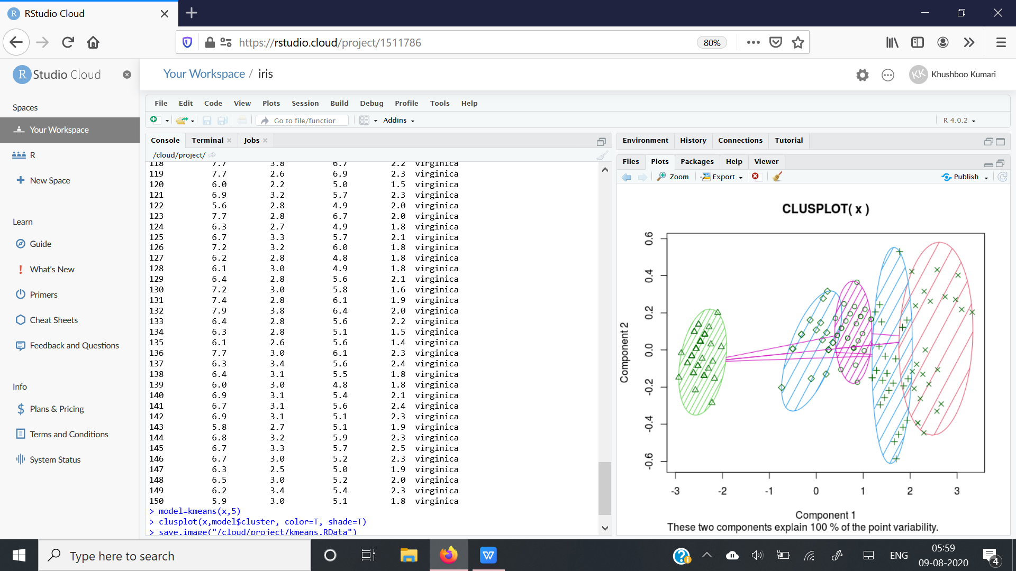

**#FOR 3 CLUSTERS**

> model=kmeans(x,3)

> clusplot(x,model$cluster, color=T, shade=T)

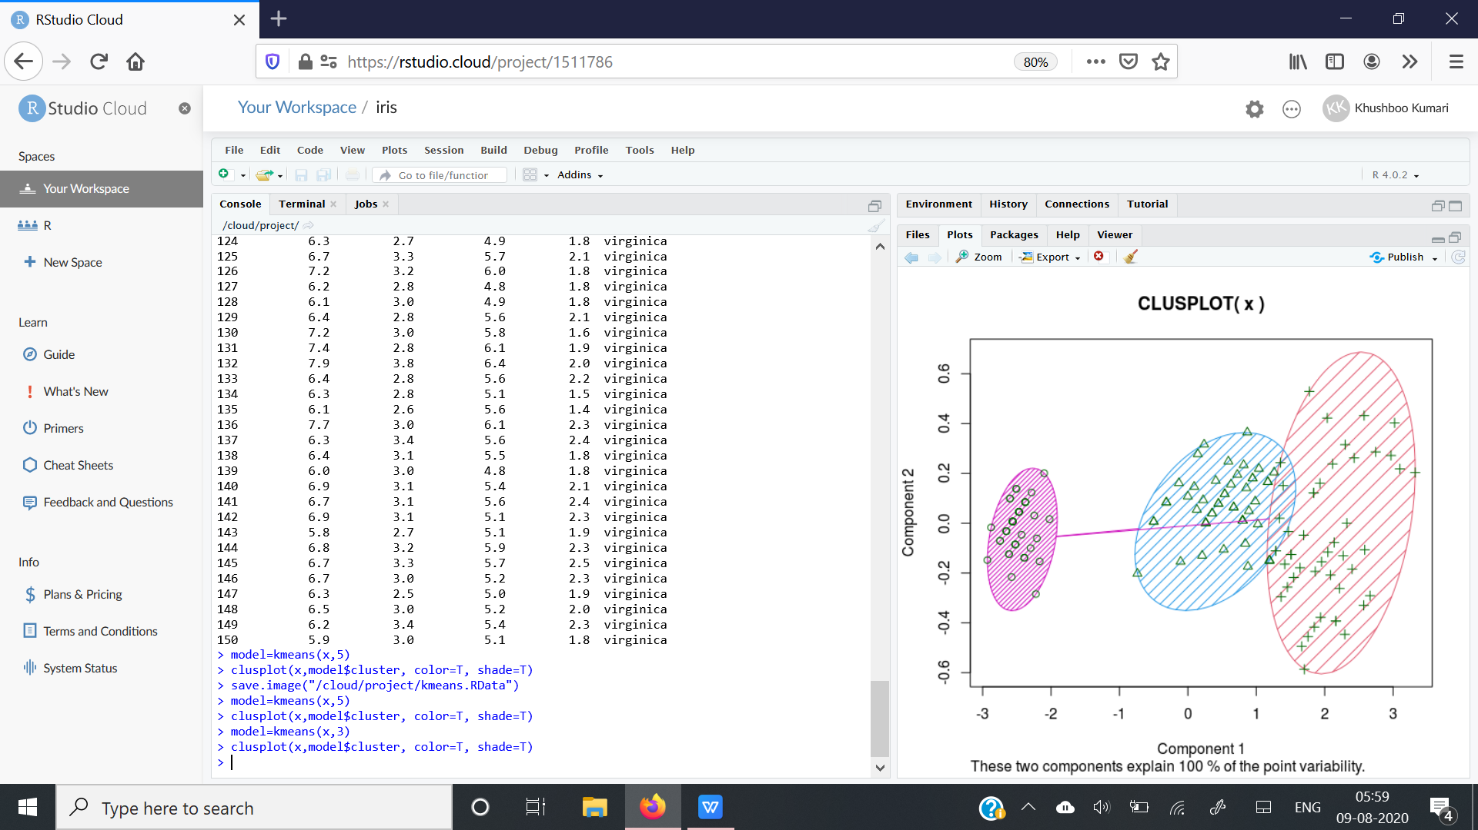

**#FOR 1 CLUSTER**

> model=kmeans(x,1)

> clusplot(x,model$cluster, color=T, shade=T)

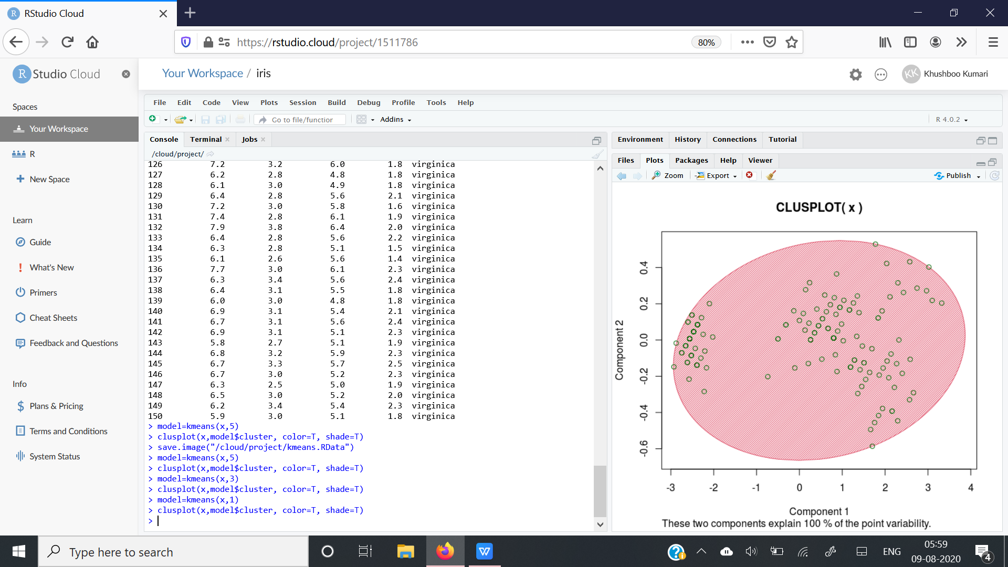

**CONCLUSION:**

Here we get to know how to do classification by using R-lang and plot graphs of different no of clusters.Also we get to know the difference of code between R and python.